Model Development Phase Template

Date | 6th July 2024
Team ID | 740141
Project Title | Garment Workers Productivity Predictions
Maximum Marks | 10 Marks

Initial Model Training Code, Model Validation and Evaluation Report
The initial model training code will be showcased in the future through a screenshot. The model validation and evaluation report will include a summary and training and validation performance metrics for multiple models, presented through respective screenshots.

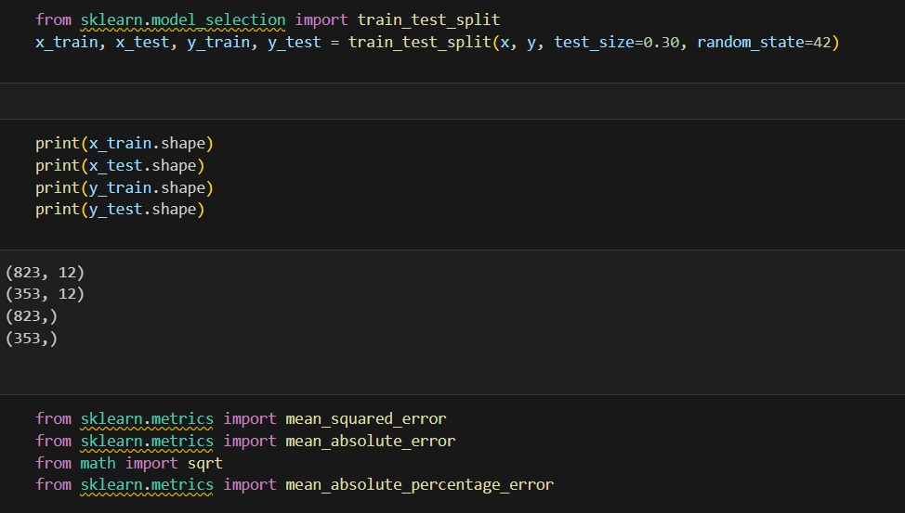
Initial Model Training Code (5 marks):

 | Summary | Training and Validation Performance Metrics
Model 1  Random Forest Regressor | Random Forest Regressor Summary  Model Parameters  - Number of Trees: Optimal number of trees determined through hyperparameter tuning.  - Max Depth: Maximum depth of the trees, optimized to prevent overfitting.  - Min Samples Split: Minimum number of samples required to split an internal node.  - Min Samples Leaf: Minimum number of samples required to be at a leaf node.  Training Process:  - Data Preprocessing: Standardized or normalized input features.  - Bootstrapping: Random sampling with replacement to create multiple training sets for the trees.  - Feature Selection: Random selection of features at each split to ensure diverse trees.  Evaluation Metrics:  - Mean Absolute Error (MAE): Measures the average magnitude of the errors in the predictions.  - Mean Squared Error (MSE): Measures the average of the squares of the errors, penalizing larger errors.  - R² Score: Indicates the proportion of the variance in the dependent variable that is predictable from the independent variables. | 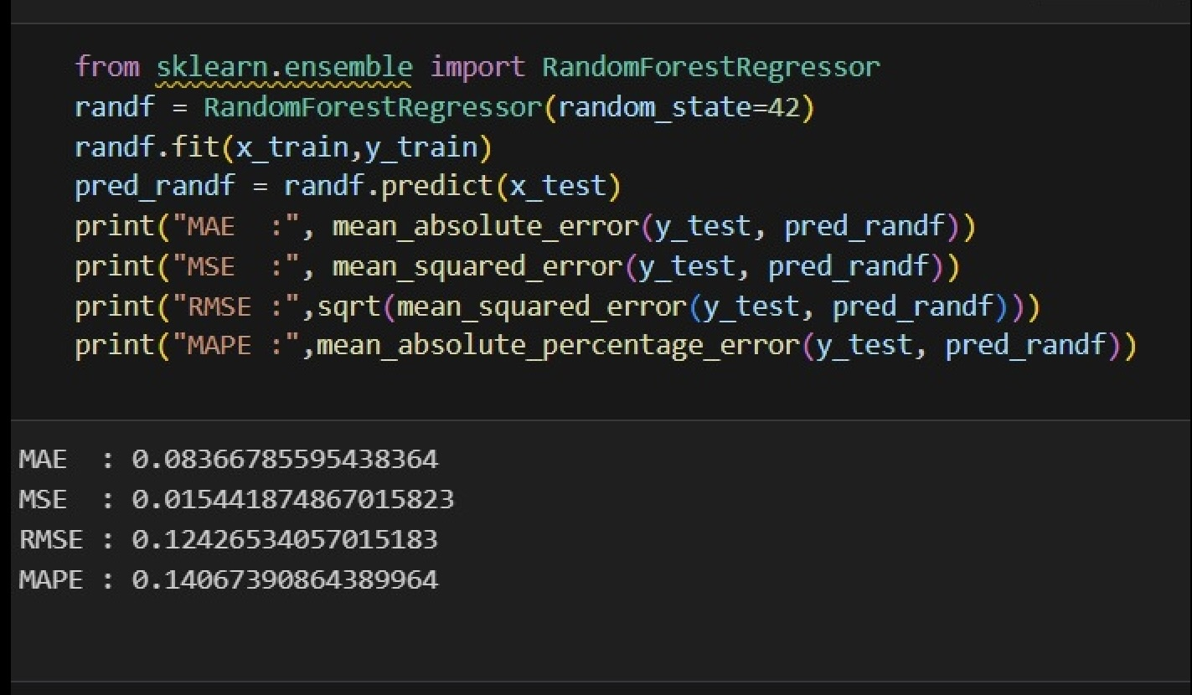
Model 2  Gradient Boosting Regressor | Gradient Boosting Regressor Summary  Model Parameters:  - Number of Estimators: Total number of boosting stages (trees).  - Learning Rate: Shrinks the contribution of each tree.  - Max Depth: Maximum depth of the individual regression estimators (trees).  - Min Samples Split: Minimum number of samples required to split an internal node.  - Min Samples Leaf: Minimum number of samples required to be at a leaf node.  - Subsample: Fraction of samples used for fitting the individual base learners.  Training Process:  - Data Preprocessing: Standardized or normalized input features.  - Initialization: Starts with an initial prediction, often the mean of the target values.  - Sequential Training: Each tree is trained on the residuals of the previous trees' predictions.  - Loss Function: Mean Squared Error (MSE) to minimize the difference between predicted and actual values.  Evaluation Metrics:  - Mean Absolute Error (MAE): Average magnitude of the errors in the predictions.  - Mean Squared Error (MSE): Average of the squares of the errors, penalizing larger errors.  - R² Score: Proportion of the variance in the dependent variable that is predictable from the independent variables. | 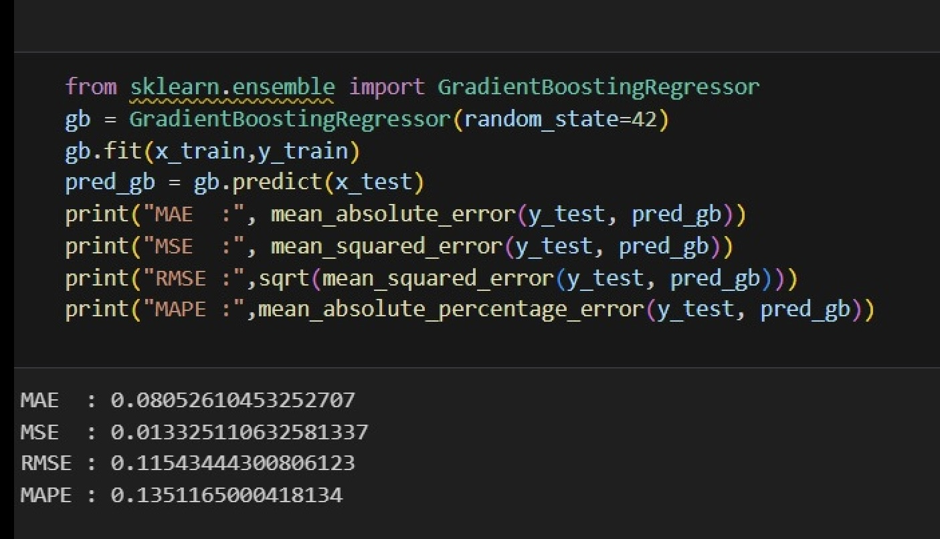
Model Validation and Evaluation Report (5 marks)

